Instructional Lab II - Resource Book - Semester 2

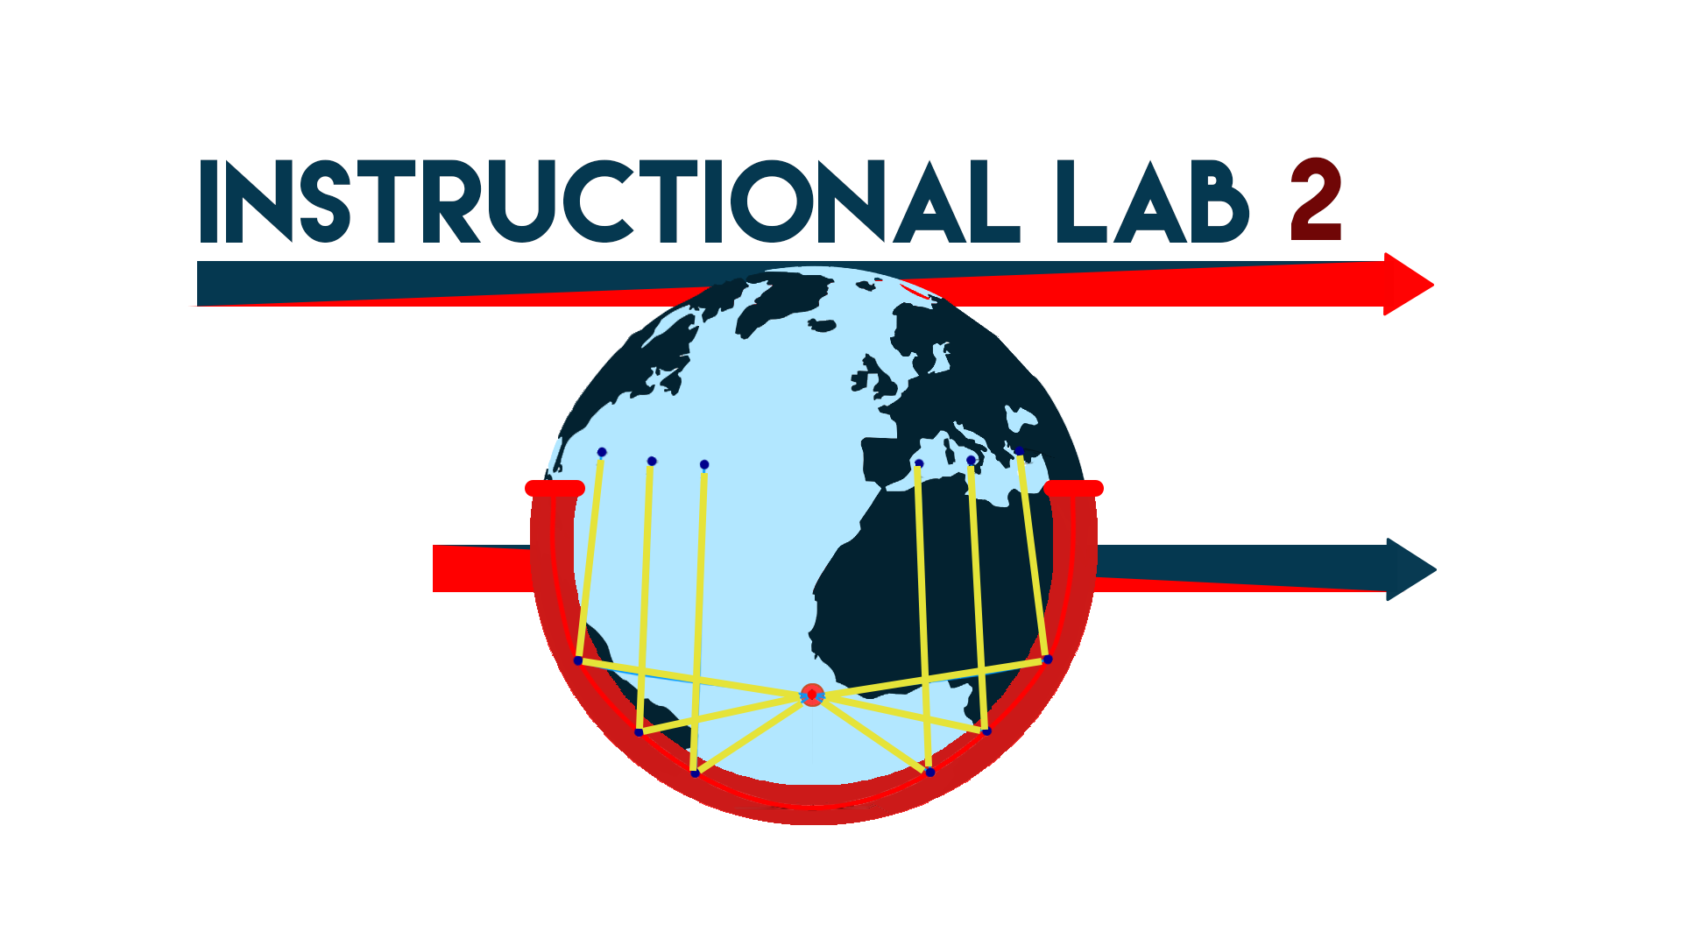

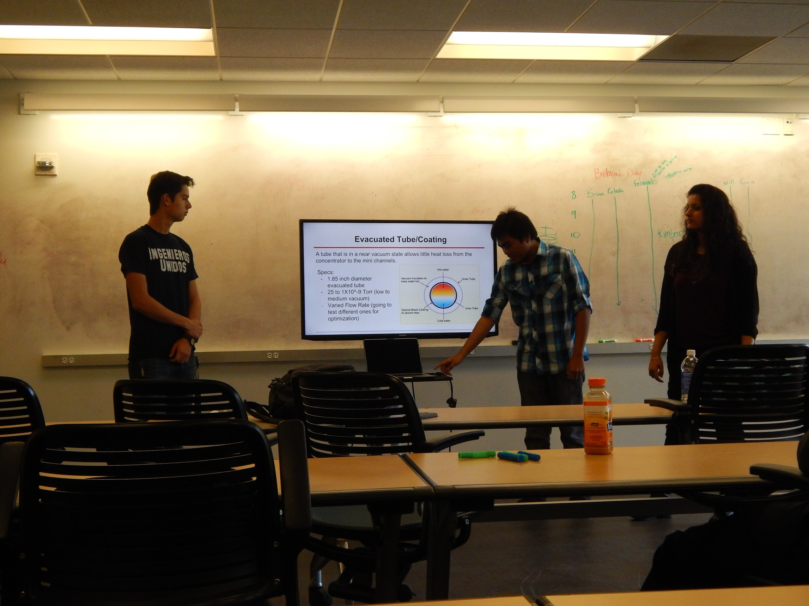

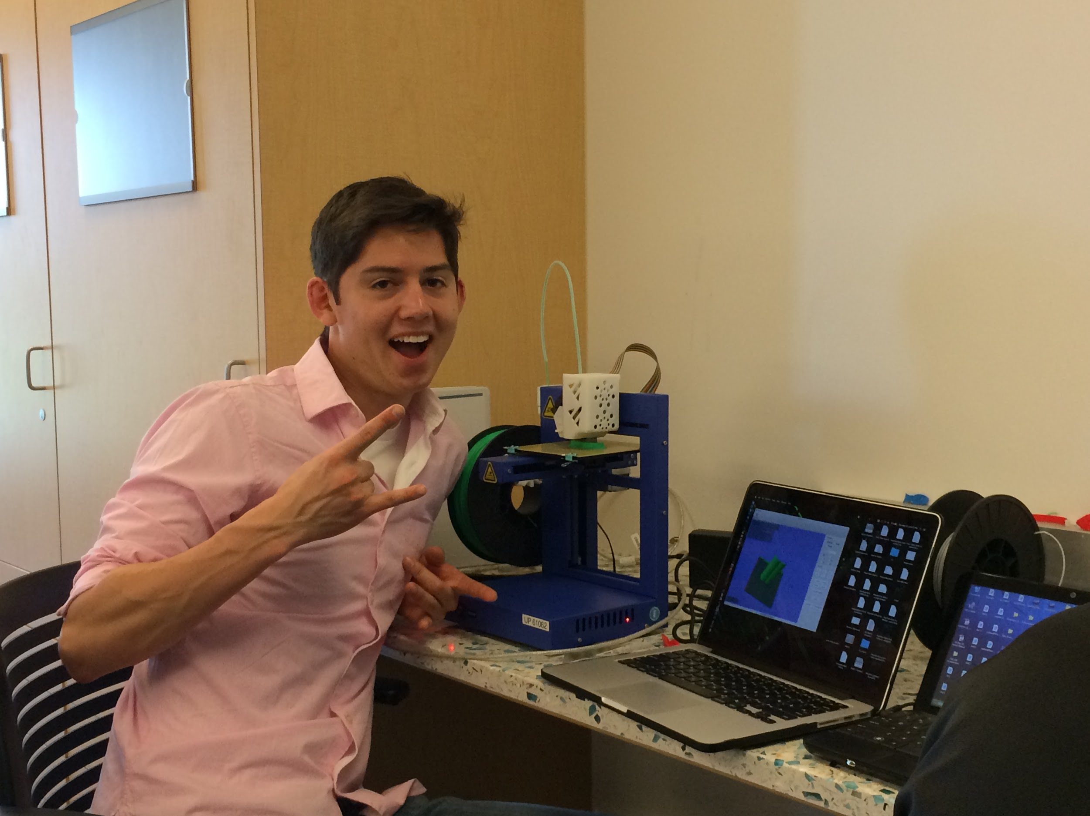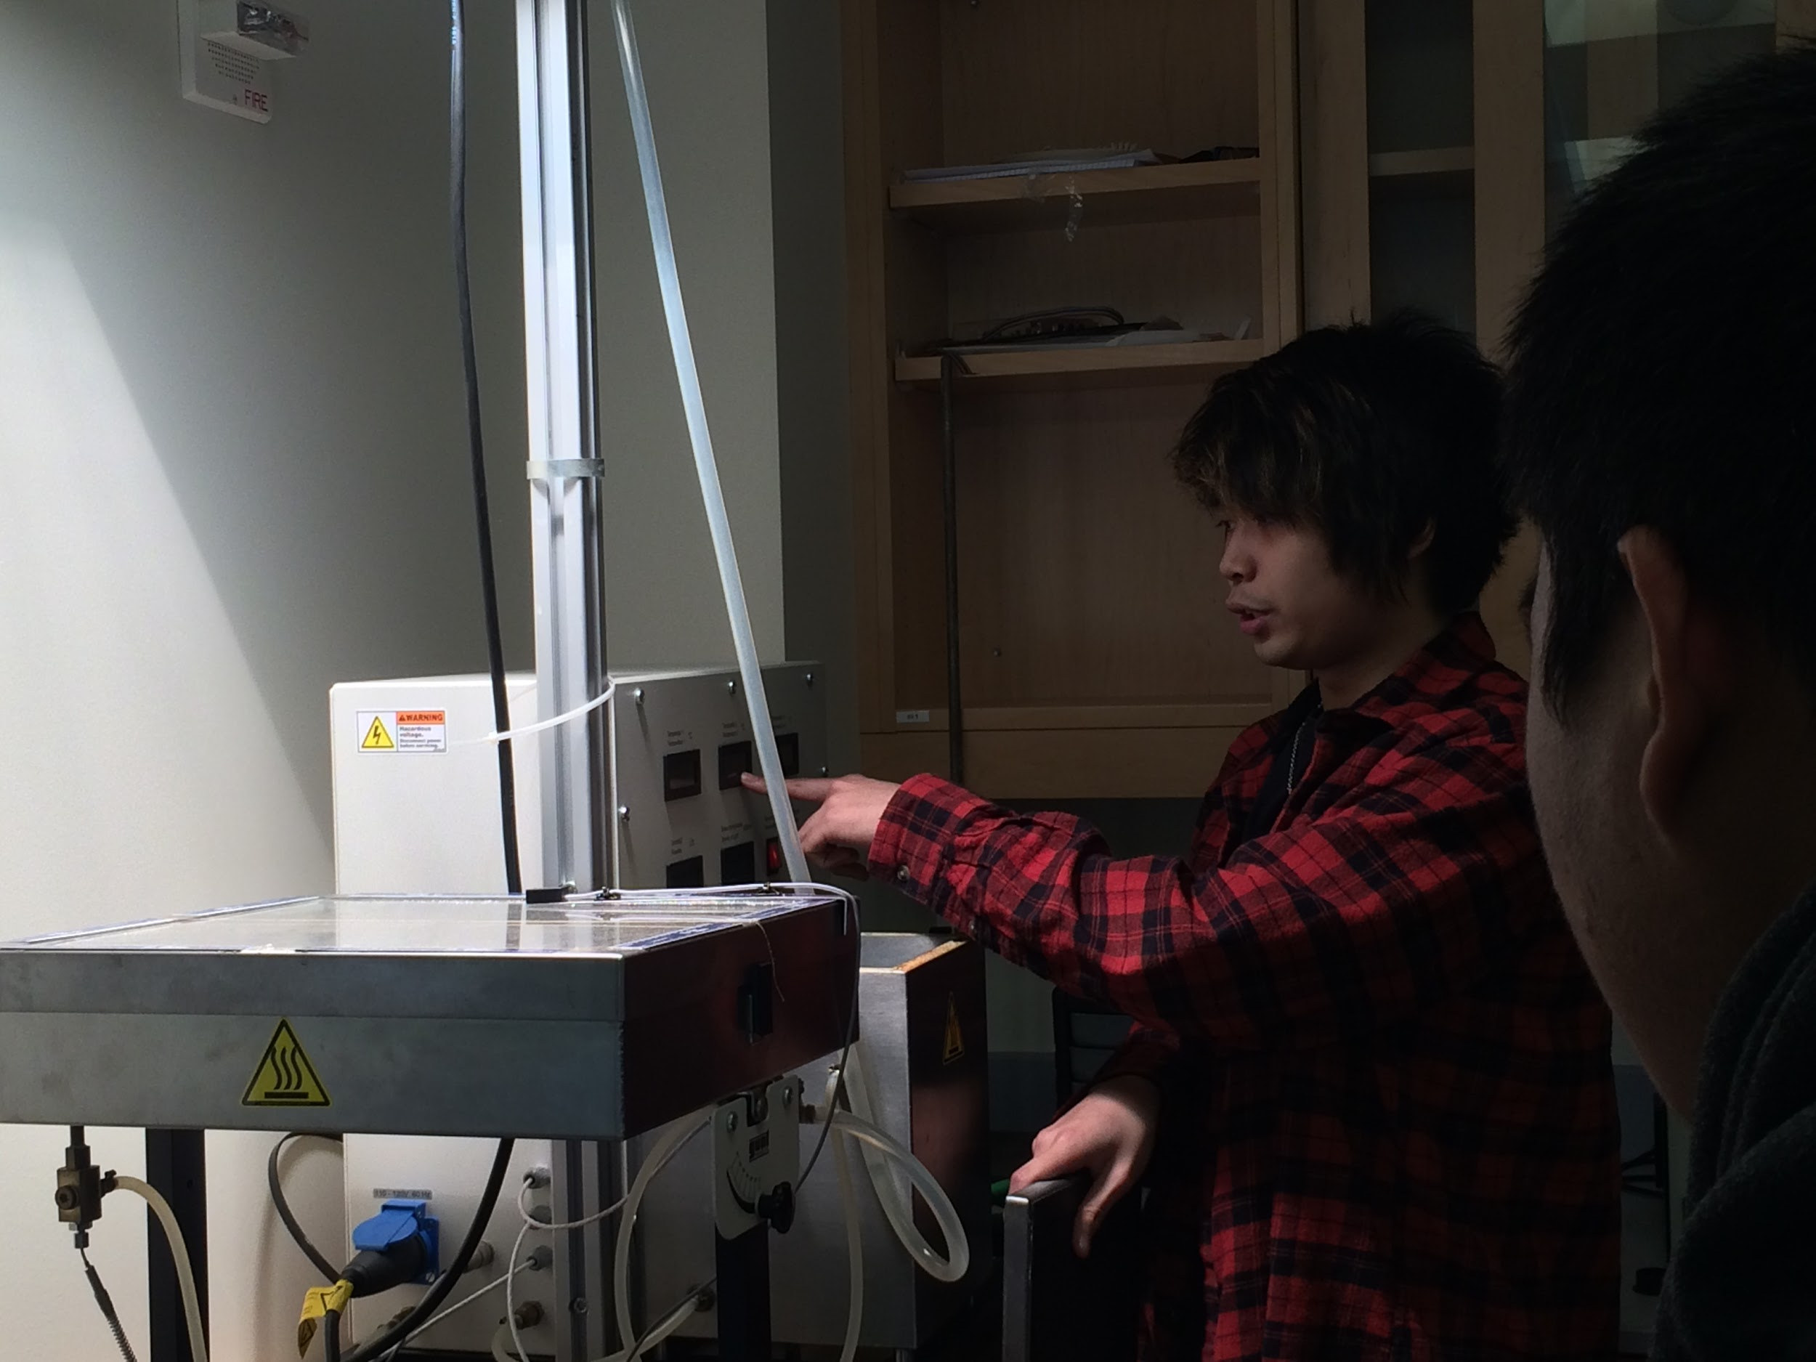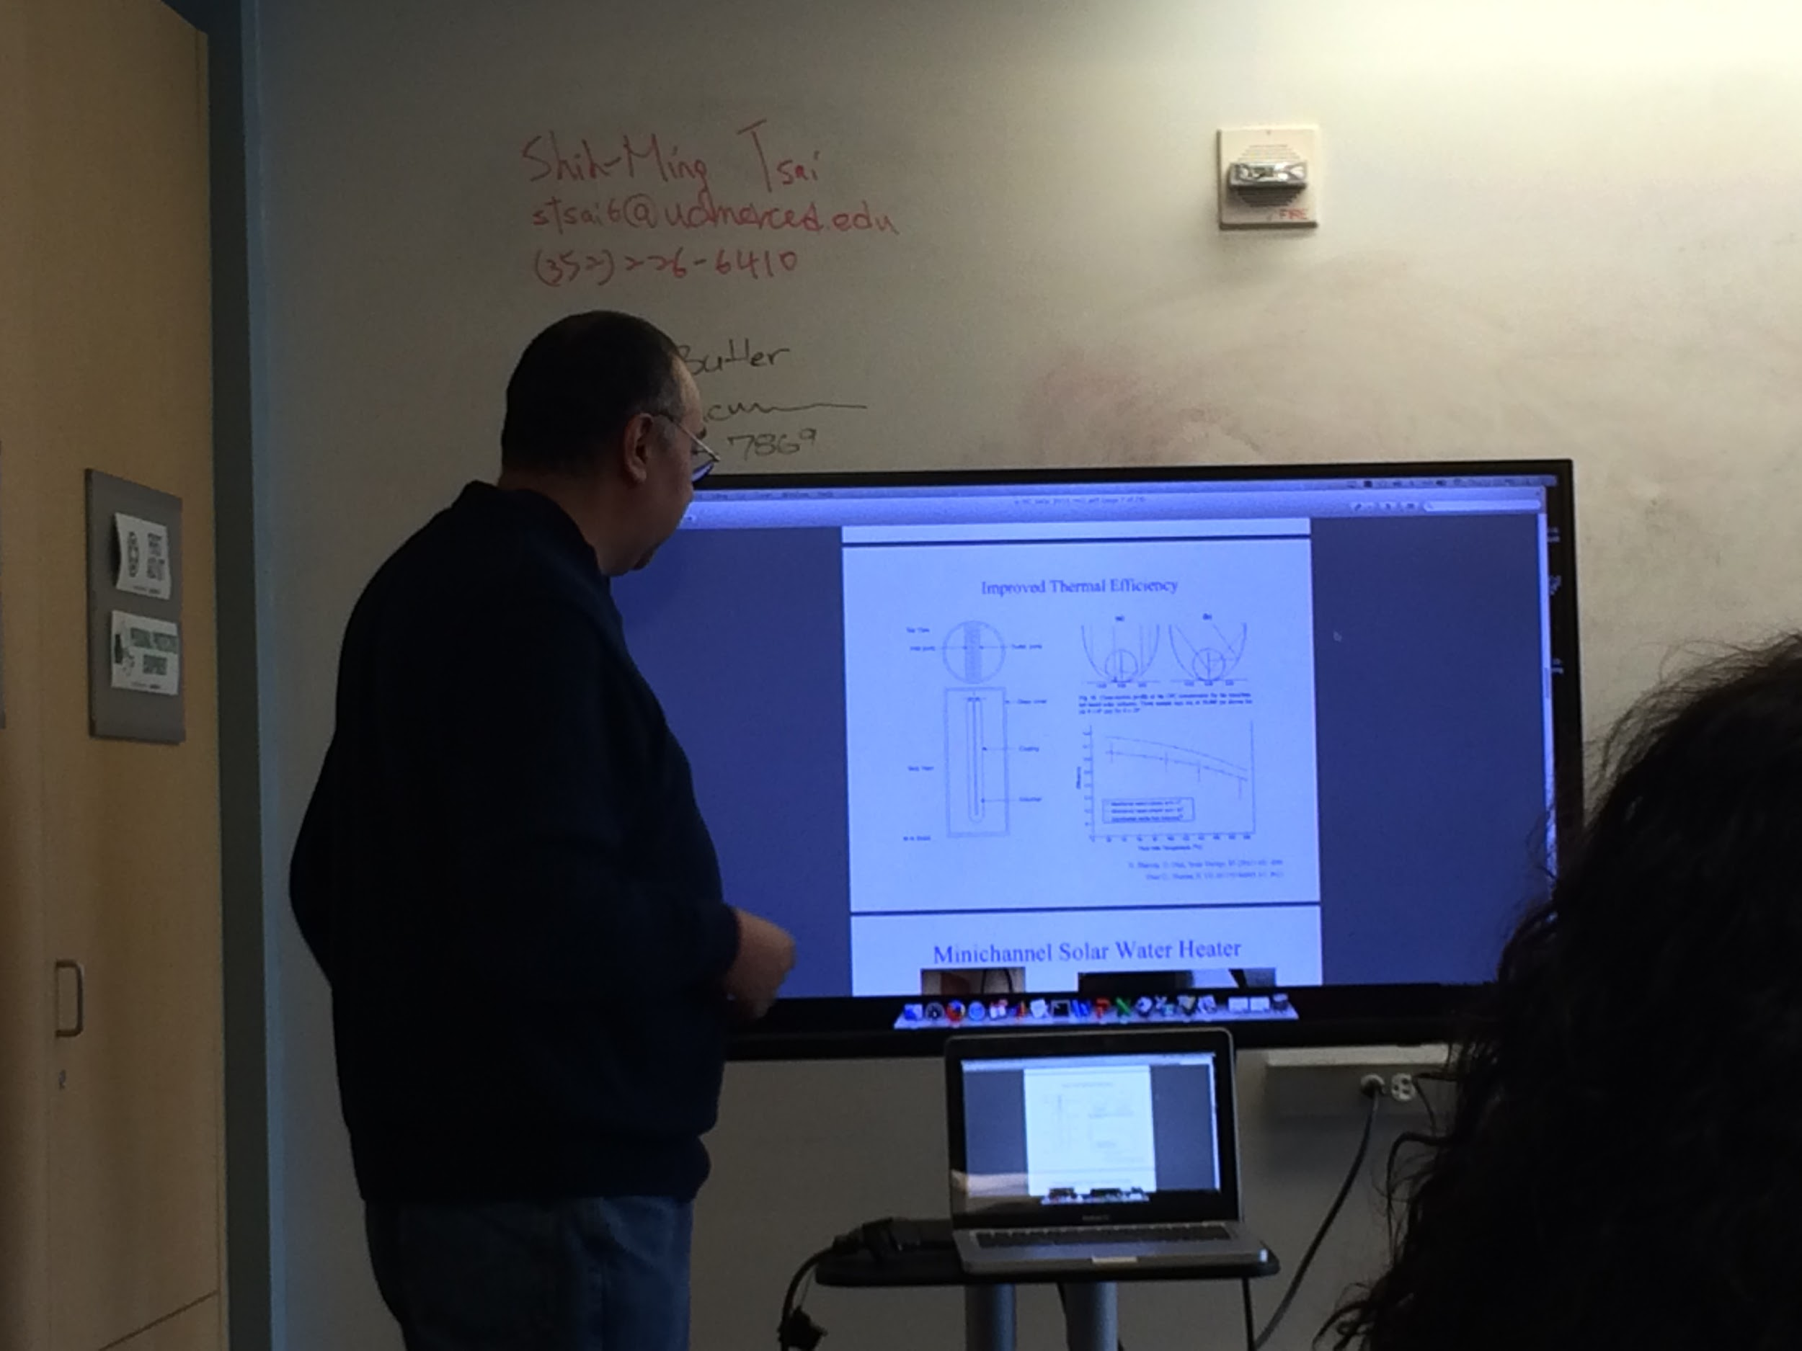

Introduction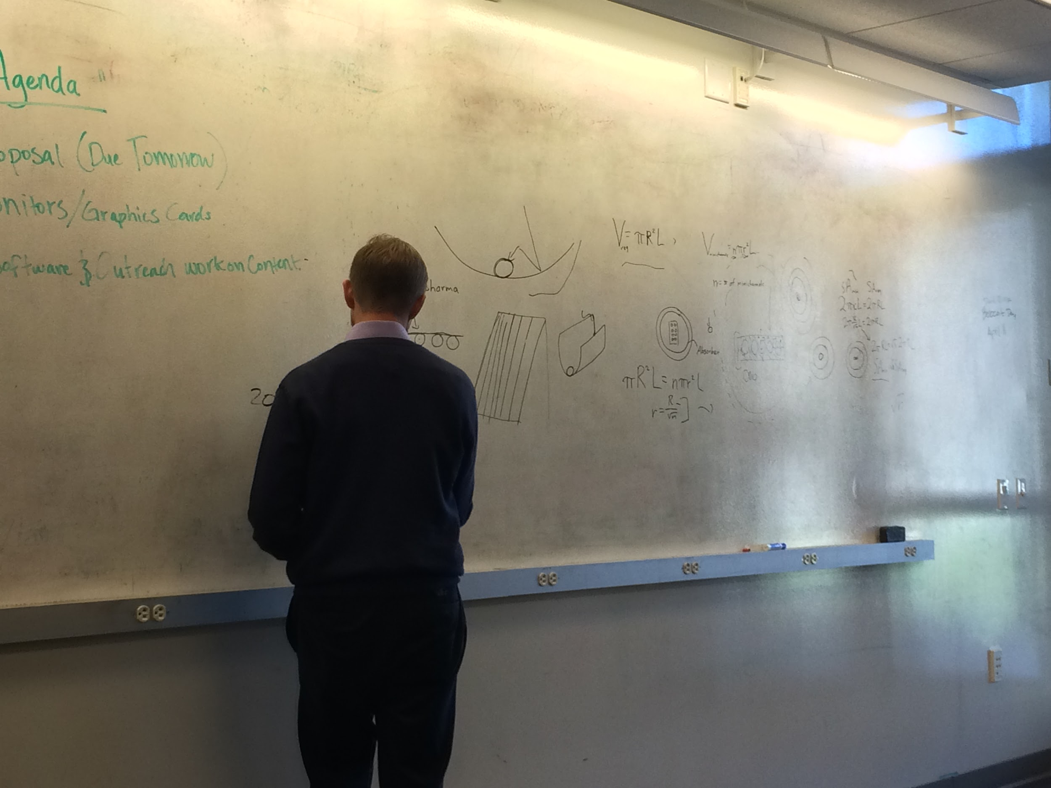

At the beginning of the fall 2015 semester we were presented with the challenge of creating a novel parabolic solar collector for the Heat Transfer Laboratory. This solar collector was designed to reach a maximum of 80% efficiency compared to the 40-45% efficiency of conventional solar collectors. This project was created due to a need for a more efficient solar collector that students, faculty, and graduates could use for educational and research purposes. As a result, the Instructional Lab 2 has set the base for this project and we have carefully described below all of the research that we have conducted through the course of these two semesters. Hope you enjoy!

Heat Transfer Research

**Heat Transfer** is the movement of thermal energy due to temperature difference. The three different modes of heat transfer are:

- Conduction

- Convection

- Radiation

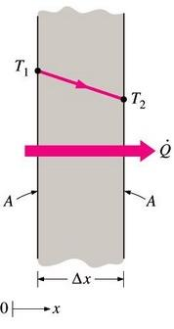

* *Conduction*: occurs as a result of a temperature gradient across a solid or fluid (ex: a hot pan on a stove)
* The amount of heat transfer per unit time is governed by Fourier’s Law:
  + q = -kAdT/dx
* Where k = thermal conductivity of the material (i.e its ability to conduct heat) , a larger k means a greater ability for heat to be transferred.

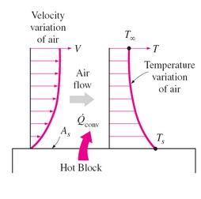

*Convection*: occurs when a surface and a fluid in motion interact in presence of a temperature difference between the two (ex: air flowing past a hot plate)

* Forced convection: occurs by external means by using a fan, pump, etc to force the fluid past a surface
* Natural convection: occurs as a result of buoyancy forces caused by differences in density as a result of temperature differences in the fluid. 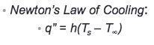

Where,

h = convection heat transfer coefficient, and depends on fluid properties, surface geometry, fluid velocity, and other

*Radiation*: is heat transfer through electromagnetic waves (ex: heat up food in a microwave) and can occur in two different ways at a single surface and between two or more surfaces.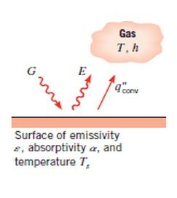

* The Stefan- Boltzmann law

For single surface: For two or more surfaces:

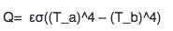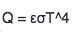

Where,

T = absolute temperature

Q = rate of heat transfer

[epsilon] = emissivity constant

[theta] = Boltzmann constant

Although, our goal is to create a parabolic solar collector, not a flat-panel one, the following image is a good representation of the heat transfer concepts that occur:

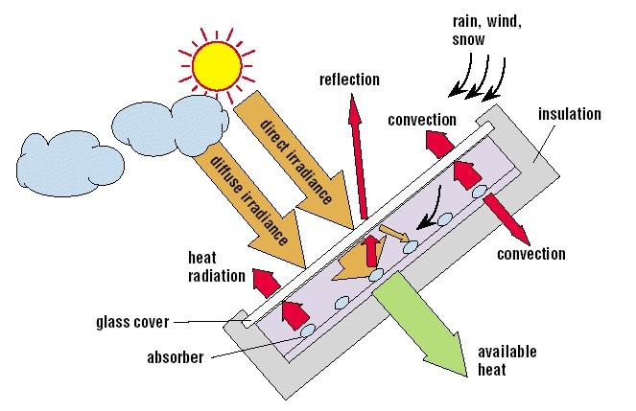

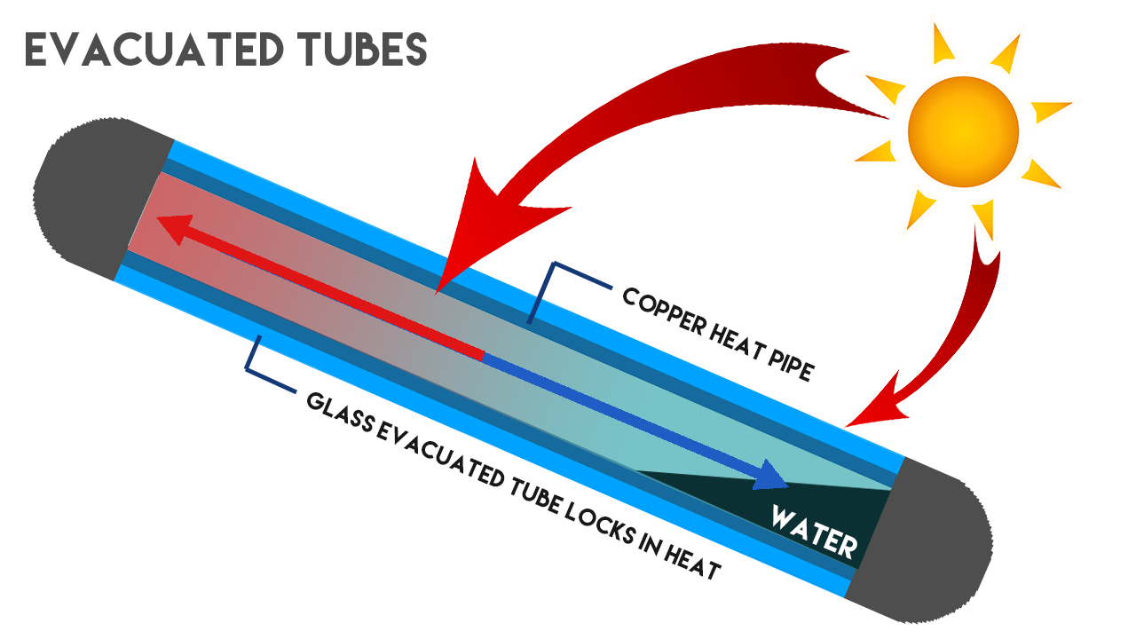

Evacuated-Tubes

Illustrator rendering by Majok Ring

Other factors to keep in mind:

* Coefficient of expansion: the fractional change in length (or sometimes volume) of a material for a unit change in temperature.
* Viscosity - resistance of a liquid to shear forces (i.e resistance to flow)
* Thermal capacity - the ability of matter to store heat
* Freezing point
* Boiling point

These factors are especially important due to the seasonal changes experienced in Merced throughout the year. In other words, an efficient solar collector should be able to work in both really high temperatures and really low temperatures when placed outside.

Solar Collector Research

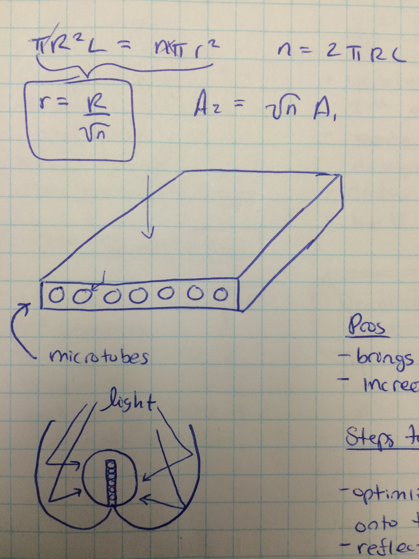Mini Channels: To start off, we will be using mini channels (also known as micro channels) in this evacuated parabolic solar collector to reduce heat transfer loss that normally occurs in regular sized channels for conventional solar collectors. Heat transfer efficiency is increased specifically by increasing the area in contact with the fluid and bringing down the thermal resistance. When designing and building the mini channels, it is important to consider optimizing light concentration on the microtubes and the reflection of sunlight after initial reflection from the micro channel tubes. The optimal dimensions for the micro channels could be calculated from scratch from the equation on the left. The variable *n* is the number of micro channels. The idea is to put the micro channels right next to each other to minimize open space and thus reducing heat loss.

The solar collector as a whole is planned to run at temperatures reaching and exceeding 150 degrees celsius in order to reach 80% efficiency. As a result, manufacturing, pressuring, and the overall design must be created with such temperatures in mind.

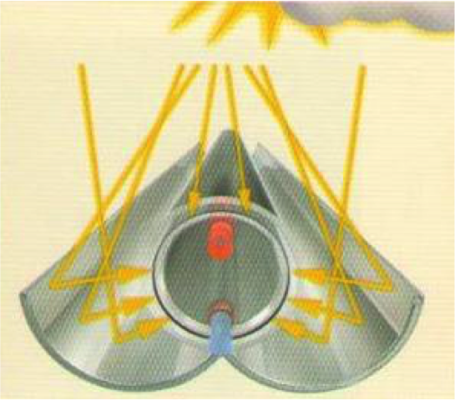

Parabolic sheet: These parabolic light focusing sheets concentrate light on the micro channels to provide more sunlight than in conventional flat paneled solar panels. The angle and positioning of the parabolic panel should be carefully considered to maximize the light available for capture.

Arduino and LabVIEW Thermocouple Device

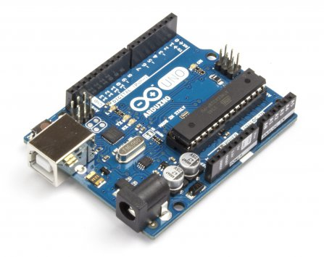

Arduinos are a cheap single board microcontroller used to make something in code interactable with the physical real environment. In this situation we will be using the arduinos, coupled with a breadboard and a thermocouple in order to read the fluid temperature at different states in our solar collector. The readings from the arduino will be in sync with real time over to the program LabVIEW in order to tabulate and analyze the readings. The code and assembly is still in the process and is expected to be completed by the end of next semester.

Evacuated Tube: The minichannels are housed in a pair of glass tubes, which prevent non-radiative heat transfer by enclosing the minichannels in vacuum. This reduces loss of heat from the minichannels by convection, keeping the operating temperature high. The target length for the evacuated tube is one meter, based on advice from our community partner. A one meter tube hits a balance of available surface area to collect radiation, and a small enough size to fit on a table or be moved to different locations. Image on next page.

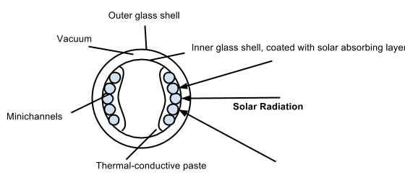

*Fig. 1: Evacuated Tube cross-section.*

First, radiation reflected from the parabolic sheet is aimed at the evacuated tube, and passes through the outer glass shell. A small amount of light is instead reflected away at this point, or absorbed by the glass; it is intended that the glass is sufficiently transparent to make that effect negligible. Second, light passes through the vacuum, and then hits the inner glass shell. Third, light is absorbed by an absorptive paint that coats the inner glass shell. That absorptive paint becomes heated due to the solar radiation, and heat is conducted to the minichannels by the thermal-conductive paste.

An alternative design is shown in Fig. 2.

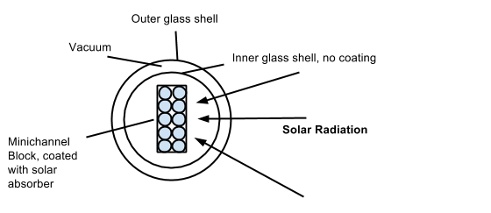

*Fig. 2: Alternate Evacuated Tube cross-section*

This design arranges the minichannels in a single block, in the center of the tube. The tube could in this case be single-walled, which is cheaper. It could either be a collection of small individual tubes connected together with thermal-conductive paste filling the small center gaps where radiation does not reach, or a single metal block with square or circular (or other shape, depending on ease of machining) channels running through it. It would be suspended inside the tube by perhaps a simple lump of styrofoam or cardboard disc that the minichannels rest in. This has the advantage of allowing heat to conduct between the flow into the minichannels and the flow out, which is more efficient.

The second design is preferable, as the glass tube is cheaper (needing only a single wall instead of two), and the heat transfer is more efficient. However, it requires the team to create the vacuum themselves, as well as apply the solar coating themselves. This may be more difficult to accomplish.

Our suggestion is to use a mason jar vacuum sealer, normally used to preserve food. The tube would need the same exit diameter as a mason jar, and the lid would need a very tight seal with fluid pipes exiting the minichannels. A possible option would be this tube: <http://www.waleapparatus.com/catalog.asp?prodid=548023&showprevnext=1>. It has a 64 mm diameter, which is close to a mason jar. It’s 1226 mm long, which is close to the target length. And it can be bought individually for near $126, including shipping. Using that single walled tube will mean the microchannels will have to be painted separately, and this vendor may be an option: <http://www.net4sale.com/Shop/pc/viewPrd.asp?idcategory=40&idproduct=76>

That solar coating has an absorptivity of .96, and an emissivity of .52, for about $25.

In the case of the double walled design, most companies won’t sell individual evacuated tubes, instead selling either a complete system of evacuated tubes to be mounted on a roof in a set of 20, perhaps with accompanying pump system, or they will sell tubes in very large quantities, at a minimum of 100. Also, sizes often preferred by most manufacturers are closer to 2 meters than one meter, which is perhaps awkward for our purpose.

Our current choice for evacuated tube is from Apricus (<http://www.apricus.com>). This evacuated tube includes a getter to remove condensation and maintain the vacuum in between the layers. The dimension for the tube is 1.8 meters ~1.85 in. by .07 in. Inside Diameter.

The first vendor is a hobby website, <http://www.electric-bike-kit.com/solar-tube.aspx> . Their evacuated tubes are closer to one half meter long, so two would have to be purchased in that case. The open ends of the tubes would face each other, with hoses connected in the center, leaving through the side of the reflector. The advantage of this product is that the tubes are sold individually, rather than in huge groups. The disadvantage is that using two separate tubes will complicate the design and assembly.

The second is a seller of government surplus, <http://www.fossilfreedom.com/products.html> . Their product is close enough to a meter, and they provide more information on their product. The advantage would be a less complicated product, with research already done. However, those tubes are only sold in packages of seven. They are still comparable in price to the other, but much of the expense will go into spares parts that may never be used.

“Our Theoretical Design”

The team has chosen a theoretical design that is much different from the current solar collector used in the Heat Transfer. We chose to use an evacuated tube that consists of two glass cylinders. To ensure higher efficiency, a vacuum seal between the two glass cylinders is recommended. Within the inner glass cylinder there will be a series of minichannels in which fluid will be pumped through. The minichannels will have the same overall volume as a typical, single channel. This allows for more surface area to collect and conduct more heat to the working fluid. The team has proposed a quantity of 4-8 minichannels made of copper material. Copper material was chosen because of its excellent heat transfer properties. The working fluid is recommended to be propylene glycol. Propylene glycol can be used in extreme cold and hot weather, which makes it suitable for Merced climate and allows us to avoid pressurizing the system. The evacuated tube will be surrounded by a double-parabolic mirror called a solar concentrator. This will allow concentration of light to the collector improving the amount of energy collected, consequently improving the efficiency.

Components of Design:

Hose:

A hose is necessary for the solar collector because it enables the fluids to looped around the system.

Diesel Delivery Nitrile Alloy Hose is the hose of our choice. Hoses Direct is the company that we’ll be buying from. We chose this particular hose for the following reasons:

* Made of oil resistant synthetic rubber
* Suitable for glycols, mineral oils, emulsion, hydrocarbons, and many other fluids.
* Can come from ¾’’ (19mm) x 50mtr Coil

Fluids:

We will be using Propylene Glycol as our fluid because it can withstand a high temperature and it is non-toxic. Propylene glycol is a water and oil mixture. High quality water will help maintain system efficiency and prolong glycol fluid life. Glycols depress water’s freezing point by providing protection to temperature as low as -70 F and -100 F. All glycols produce acids in the presence of air. The acids can reduce pH and cause corrosion. To keep corrosion under control, we maintain metal in a passive rather than an active state. The following criteria was used in determining the right type of fluid that should be used for solar thermal application:

1. High specific heat: 2.5 kJ/kg.K
2. Low freezing point: -59 degrees Celsius
3. High thermal stability at temperatures up to 350 F (177 C)
4. Boiling point: 150 degrees Celsius
5. Good corrosion protection
6. Readily available and inexpensive
7. Easy to install and maintain

Some things to note:

* Propylene glycol could be used in aluminum or copper piping.
* The fluid should be changed 3-5 years for maintenance and prevent the fluid from turning into glycolic acid.

Sensors:

Sensors are necessary for a solar collector in order to measure and calculate different aspects including temperature, flow rate, pressure, and intensity of light. The specific sensors used for these different purposes are thermocouples, flow sensors, pressure sensors, and a heliograph.

1. Thermocouples - are used for directly measuring temperature.
   1. Specs -
      1. Probe K Type
      2. Model #WZP
      3. Accuracy: Class B. +/-0.30C at 0.0 C.
      4. Alpha: 0.00385
      5. Tip length: 34 mm from the end of thread.
      6. Mounting thread: 1/8" NPT.
      7. Maximum temperature: 420C
      8. Price: $9.60-14.50
   2. Manufacturer(s) - Shanghai Feilong Meters & Electronics Co., is one of the area's high technology enterprises and research institutes and has jointly developed a series of electrical and electronic products sold throughout the country.
   3. Link: <http://www.alibaba.com/product-detail/Thermocouple-Probe-k-types-pt100_358299933.html>
   4. Why? - Thermocouples are very necessary especially in a solar collector that is affected by solar energy and heat. There needs to be a sensor to regulate and keep track of increases or decreases in temperature.

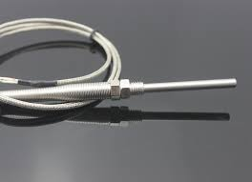

1. Flow sensors - all measure how much mass, or fluid, per time is passing through a given control volume. Since we are forcefully moving fluid through our system with a pump we must check and regulate the fluid flow rate.
   1. Specs-
      1. Item: Flowmeter
      2. Price: $351.25 for each (only need one)
      3. Product # 4NMZ9
      4. Type: Variable Area
      5. Max. Pressure: (PSI)3500
      6. Connection Size: (In.)1/2 FNPT
      7. Max. Temp: (C) 115
      8. Length: (In.)6-5/8
      9. Width: (In.)2-1/16
      10. Height: (In.)2-3/8
      11. Housing Material: Brass
      12. Fitting: Brass
      13. Flow Range: 0.5 to 5 gpm
      14. Accuracy: (%)+/-2% Full Scale
      15. Flow Material: Water and Other Liquids
   2. Manufacturer(s) - Hedland Flow Meters, manufacturer of quality flow measurement solutions for over 33 years. They provide cost effective flow measurement in the following applications: oil, phosphate esters, water, water-based fluids, air, and other compressed gases.
   3. Link: <http://www.grainger.com/product/HEDLAND-Flowmeter-4NMZ9?functionCode=P2IDP2PCP>
   4. Why? - This sensor is necessary due to the flow of liquids throughout the minichannels in the solar collector. In order to measure the fluid flow rate a flow sensor is necessary.

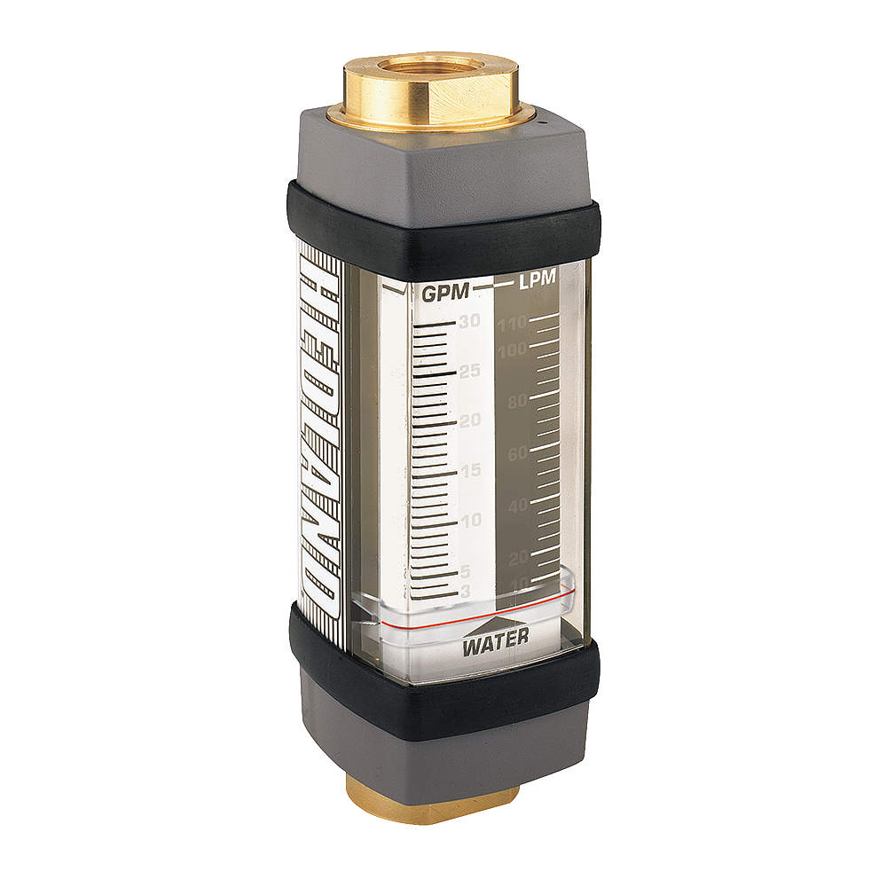

1. Pressure sensors - measures pressure, typically of gases and liquids, pressure is an expression of the force required to stop a fluid from expanding.
   1. Specs - (needs to be customized) Regular specs
      1. Product # DMP331
      2. Price for custom: $100-210
      3. Pressure Range: 0 to 0.1 up to 40 bar g, abs, compound and negative gauge
      4. Accuracy: 0.35%, 0.25% or 0.1% FS
      5. Output Signal: 2 wire 4-20mA, 3 wire 0-20mA or 0-10Vdc
      6. Electrical Connections: DIN plug, Binder, M12, IP67/68 cable gland or field housIng
      7. Pressure Connectors: 1/4 BSP male DIN3852 or EN837, 1/2 BSP male DIN3852, EN837, flush or open port, 1/4 NPT male, 1/2 NPT male, M10 male and M12 male
      8. Media Compatibility: SS316L diaphragm and process connection with FKM, EPDM or all welded seals.
      9. Media Operating Temperature Range: -40 to +125 degC (custom sensor needed)
      10. Special Options: ATEX and IECEx Intrinsic safety gas or dust, Baro and Compound ranges, SIL2 Approved electronics
      11. Weight: ~140 g
      12. Dimensions: 26.5 mm diameter
   2. Manufacturer(s) - SensorsONE is a company that specializes in measurement instrumentation products, such as this precision pressure transmitter. They also create and customize sensors to fit a specific application.
   3. Link: <http://www.sensorsone.com/dmp331-precision-pressure-transmitter/>
   4. Why? - Pressure sensors are necessary to any mechanism that uses pressure. In the solar collector pressure is utilized to stop the fluid flowing through the minichannels from expanding. This helps in order to avoid leaks and evaporation of a liquid.

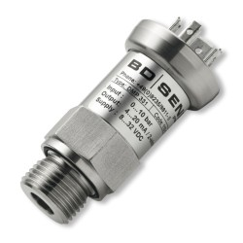

1. Heliograph - heliography is the measurement of the duration and intensity of sunlight. A heliograph is the instrument used for measuring the intensity of sunlight.
   1. Specs -
      1. Model # - 8235
      2. Size: 1X1 ft
      3. Price: $50-100
   2. Manufacturer(s) - Established in 1979, Yuyao Shenma Educational Equipments Co., Ltd. is a professional manufacturer of general teaching apparatus in whole sets and optical microscopes. Their products are widely used in the labs.
   3. Link: <http://yysm.en.alibaba.com/search/product?_csrf_token_=1e9eedcmcow7f&IndexArea=product_en&SearchText=heliograph>
   4. Why? - Heliographs help in order to measure the intensity of light on a mechanism. Especially useful for the solar collector.

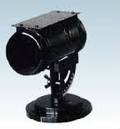

Water/ Fluid Tank:

A water/fluid tank is used to store and regulate the amount of water or liquid flowing throughout the entire solar collector system. It holds and keeps intact the fluids needed in order to convert light into usable energy.

1. Specs -
   1. Model Number: HES100
   2. Inner tank: 1.5mm thickness SUS3042B stainless steel
   3. Out tank: Galvanized steel
   4. Insulating Layer:Polyurethane---50cm
   5. Heat exchange: TU2 Copper pipe
   6. Electric Heater:1500W
   7. Price: $500-1000
2. Manufacturer - Zhejiang Hurras Solar Energy Technology Co., Ltd is a private owned company founded in 2002. They focus on providing customers with high quality and most efficient solar heating system design and industrialization. With the global growing consumption of energy and increasing demand for Green Energy they stand together with customers and partners in order to strive for the best solution.
3. Link: <http://www.alibaba.com/product-detail/Pressurized-solar-collector-tank_220503816.html>
4. Why? - Solar thermal systems use solar energy for heating water. Fluid inside the collector absorbs the energy from the light and the fluid gets warmer. Hot fluid is then pumped to the hot water tank in which it gives off its heat through the coil.

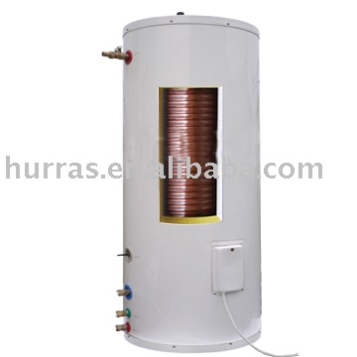

Valve Manifold

The purpose of having a Valve Manifold is to transport the hot a water and cold water from the mini channels to the water tank. We will have a hoses that are connected to the valve manifold that will transport cold water from the tank to the mini channels the water will flow through the mini channels which at the point the water will heat up and then a second hoses will transport the hot water to the water tank.The Valve Manifold will be manufacture to our specifications.

1. specs -

i. brass material

ii. the size of the vale would depend on the diameter of the hose

1. manufacturing-

The hose could be purchased from [www.ldvalve.cn](http://www.ldvalve.cn) or from any hardware store the dimesion of the valve would come from the dimesion of the hose (or it be manufactured to our specifications through Professor Diaz’s contact ).

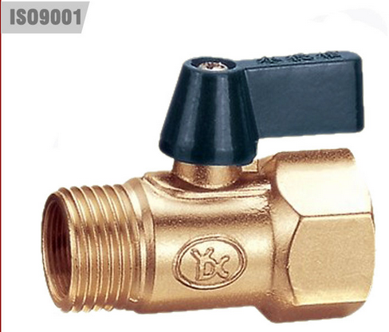

Housing

The purpose of having a housing frame for the solar collector is to would be for stabilization and to house the solar collector. The frame would consist of steel with a cold finished and the frame would be build to fit the solar collector dimensions which would be around 1 meter long..

1. Specs-

i. 0.02 x 0.03 x 1.47 meters (or something that would meet the solar collector specifications)

1. steel frame with a cold finish

iii.Long lifespan

IV. Rust and corrosion resistance

1. Manufacturing-

There two way we can go around getting the steel frame for the solar collector we can either order all the part that we will need and build it ourselves or we can order a custom made one from http://www.alibaba.com/product-detail/Mirror-stainless-steel-frame-made-in_1929227995.htm

Light Source:

* Color spectrum of the sun
* 1000 watt
* [http://www.dhgate.com/product/2014-etl-ce-rohs-approved-mar-ii-1200w-led/178689271.html?recinfo=6,2,4#cpoff-4-5|null:2](http://www.dhgate.com/product/2014-etl-ce-rohs-approved-mar-ii-1200w-led/178689271.html?recinfo=6,2,4#cpoff-4-5%7Cnull:2)

Pump:

1. There are a series of pumps sold by Thermo Dynamics LTD. The following is a chart for which models can be used under certain variables. The group has not yet decided the Flow Range and the port sizes32

|  |  |  |  |
| --- | --- | --- | --- |
| **Model** | **Flow Range**  **(L/min)** | **Flow Range**  **(USGPM)** | **Port Sizes** |
| [P24070M & P24070EM](http://www.thermo-dynamics.com/sizing_guides/solar_pump_guide/psi_vs_usgpm/P24070M_12V_psi.html) | 0.3 - 2.4 | 0.1 - 0.6 | 3/8" FPT |
| [P50140M & P50140EM](http://www.thermo-dynamics.com/sizing_guides/solar_pump_guide/psi_vs_usgpm/P50140M_12V_psi.html) | 1.0 - 5.0 | 0.3 - 1.3 | 3/8" FPT |
| [P118330](http://www.thermo-dynamics.com/sizing_guides/solar_pump_guide/psi_vs_usgpm/P118330_12V_psi.html) | 2.0 - 12.0 | 0.5 - 3.2 | 1/2" FPT |

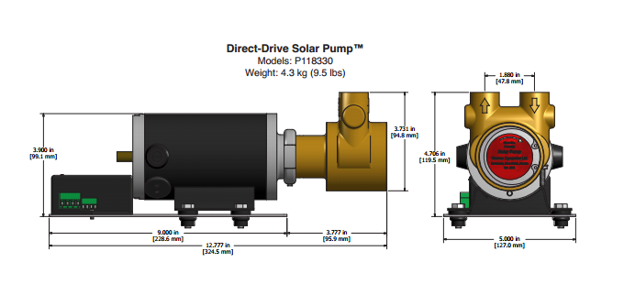

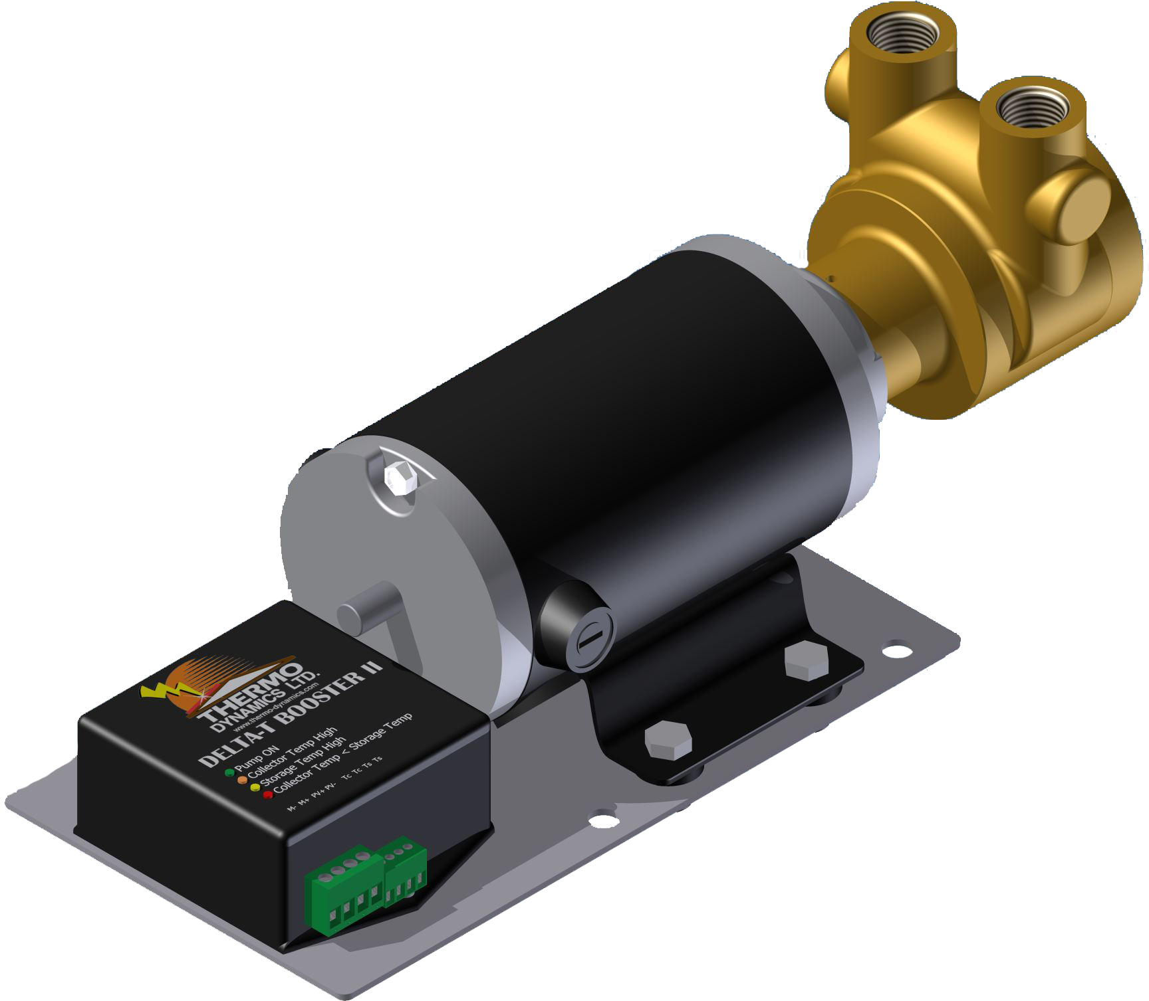

The Companies brochure for their solar pumps:<http://www.thermo-dynamics.com/pdfiles/brochures/Solar_Pump_July11.pdf>

The sizes of the different models are on the last page.

The following is chart telling the pressure drop per each foot for copper pipes. This includes other variables such as thickness of the pipe and the diameter of the pipe.

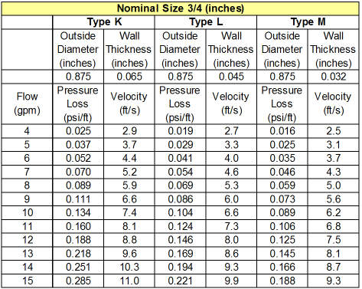

Solar Concentrator (Reflector):

The purpose of a Solar Concentrator is to concentrate light to our collector area, allowing more energy to be absorbed by the collector. The concentrator will have a double parabolic profile that will surround the evacuated tube collector such as the example pictures below.

Design of our parabolic profile has not yet been optimized. However, there are several manufacturers that offer standardized concentrators. The specifications of those concentrators can be seen in the table below. Most manufacturers offer customized specifications and will fabricate a concentrator to the consumer’s choice.

The purpose for using a solar concentrator is that users can collect more light than they would using a collector alone. By concentrating the light on the collector, more energy is absorbed, therefore, improving the efficiency and quality of our design.

There are parabolic troughs sold in China that match the length of our apricus evacuated tubes.

They are $50/$100 a set and offers a high 95% reflectivity.

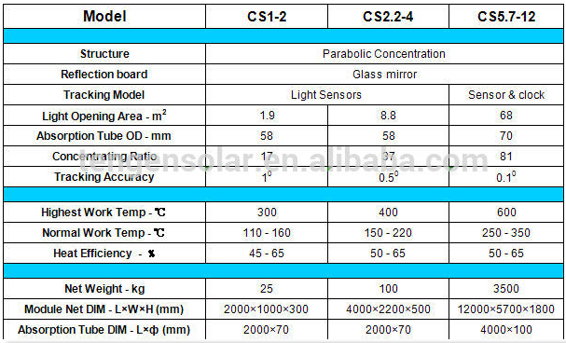

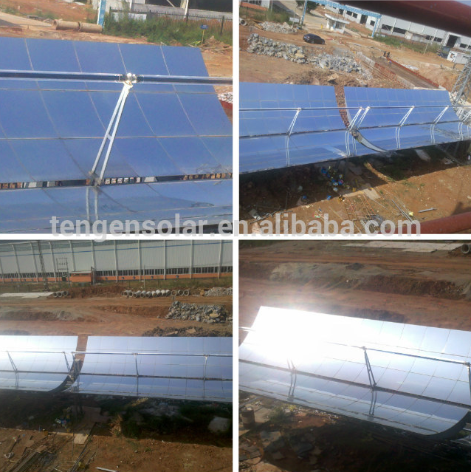

Manufacturer: Optiforms

Website: <http://www.optiforms.com>

Price: Not available (contact seller as prices may vary depending on specifications).

The table and schematic below are found from the manufacturer Optiforms. The table provides basic dimensions of their standardized parabolic reflectors. Any profiles not listed may be inquired about with the sales department through email.

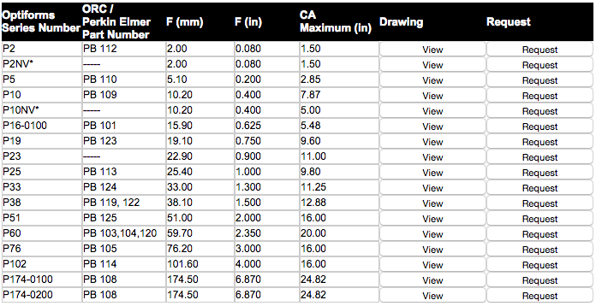

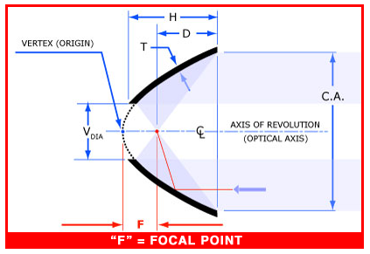

***Alternate Manufacturer: Phoenix Electroformed Products Inc.

Website: <http://www.phoenixelectroforms.com>

2nd Semester outline: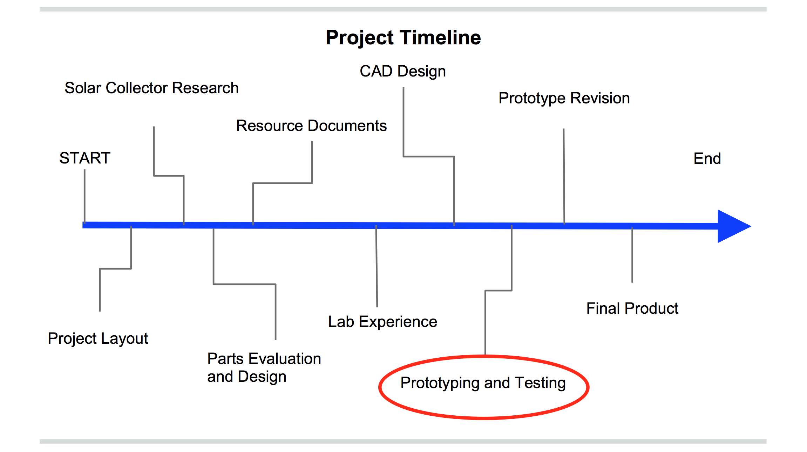 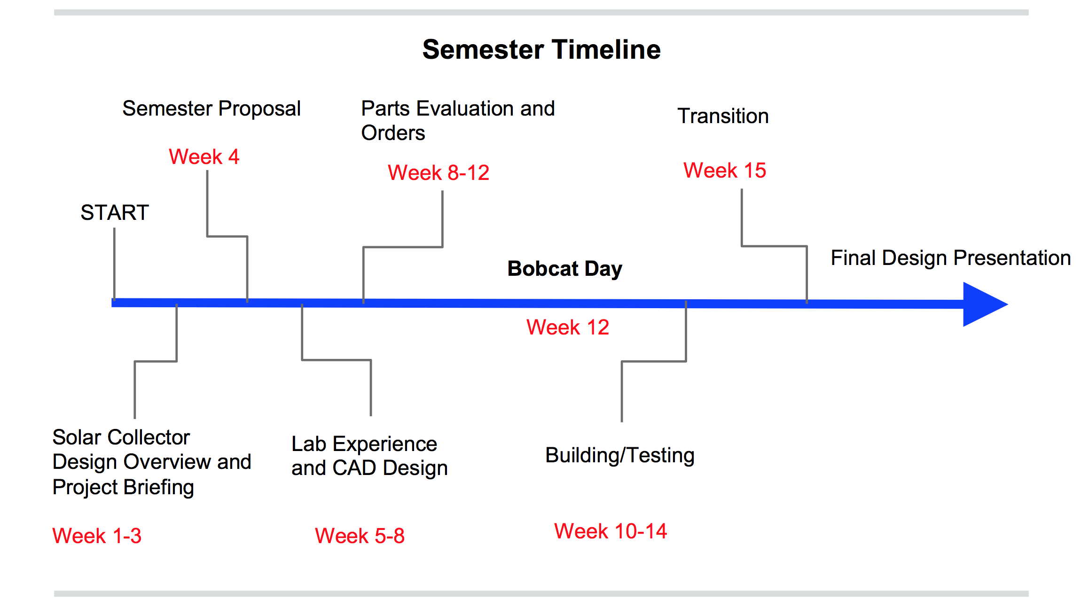

The Preliminary Design Review Powerpoint on myBox has a detailed overview of what we have accomplished so far during the 2nd semester.

Weeks 1-7 Research/Lab Experience/CAD Design

The semester started with familiarizing everyone with solar collectors, getting lab experience, and creating CAD drawings of the design. The first few weeks included presentations by individual members on an aspect of the solar collector. The presentations began with professor Diaz and his powerpoint on solar collectors.

Juan - Overview presentation on solar collector

Raymond - Presentation on microchannels and surface area math

Joseph - Presentation on vacuum tube and concentrators

Josh - Presentation on Getters

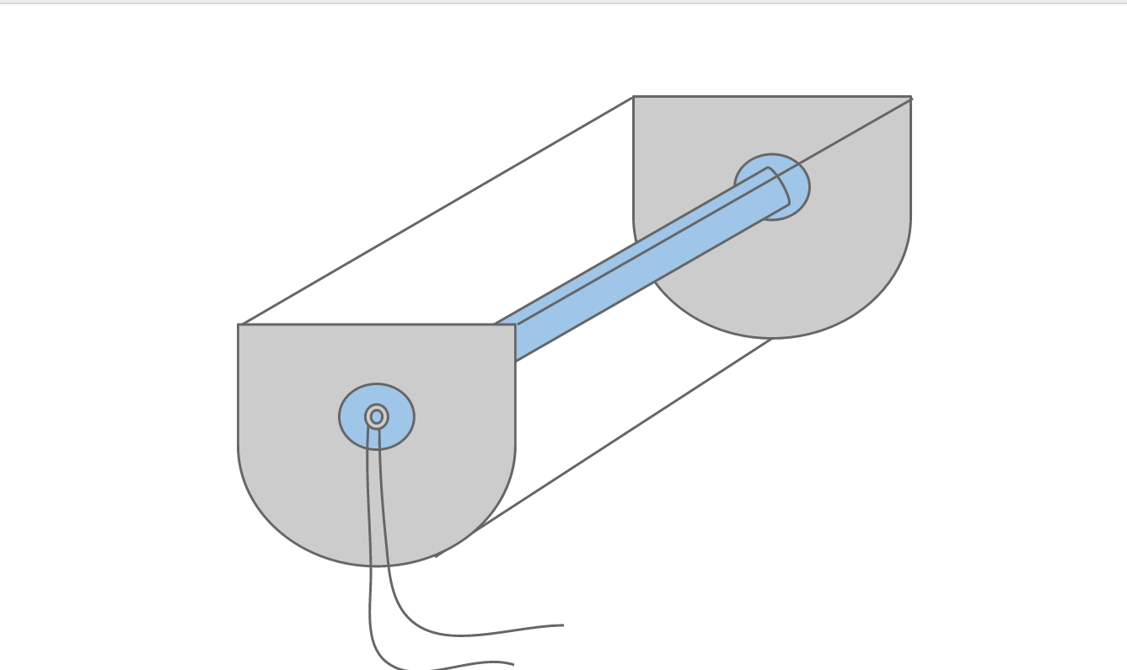

Here is an early sketch of a design suggestion by Joseph during his presentation.

Working concurrently with research is the CAD team; Juan, Josh, Majok, and Jacob. Here are some drawings they completed during the semester.[1]



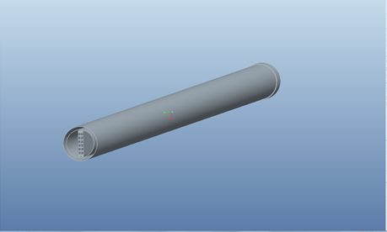CAD: Jacob Clark

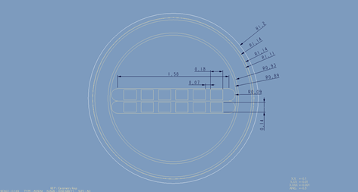CAD: Jacob Clark

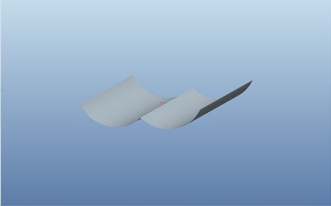CAD: Juan Hernandez

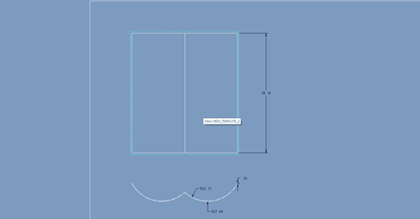CAD: Juan Hernandez

Roof Day!

Learning about solar collectors also involved exploring real life applications for it. Earlier in the semester the team was invited to look at the solar collectors on the roof and see the current designs. Sergio gave us a tour of the Engineering 2 roof, going over details about the current solar collectors. The team took dimensions and notes during the tour. Most of the team members have never seen industrial solar collectors in person so it was a fun and educational experience.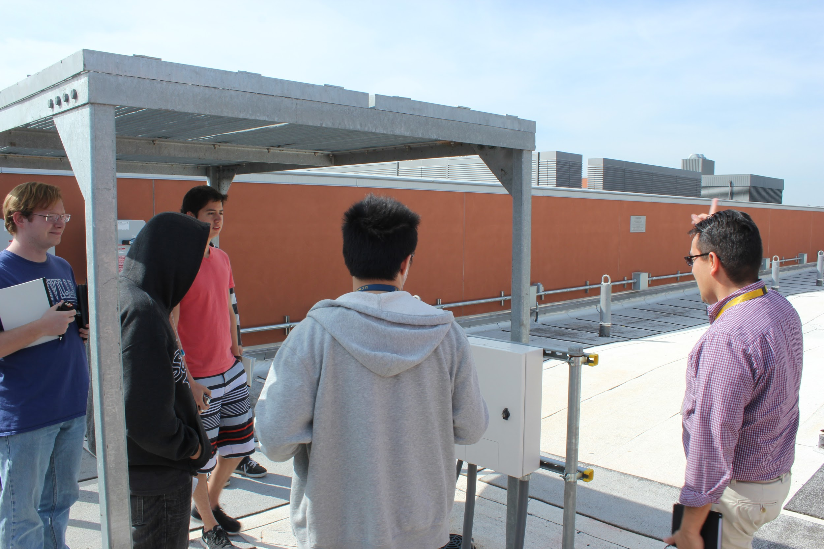

[2]

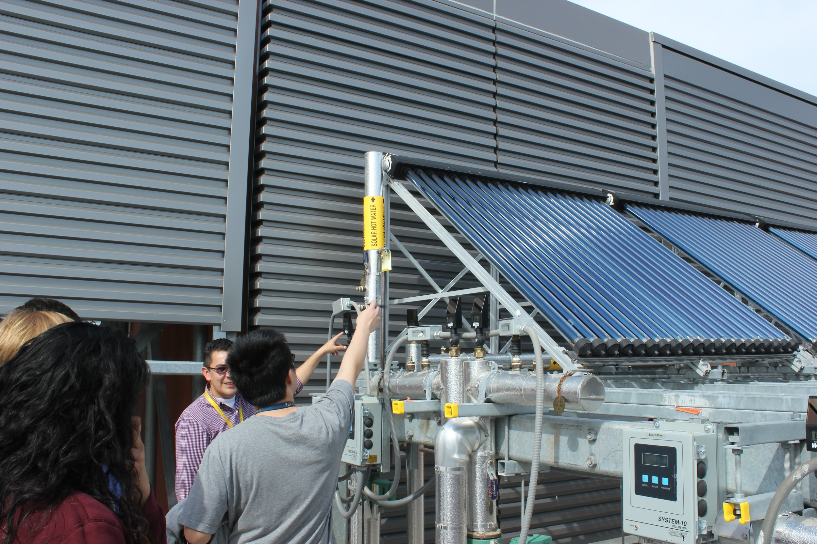

Weeks 8-12 Ordering Parts

One of the challenges with ordering parts for the solar collector is that most of the components are hard to find on the market. One example of this are the copper microchannels, which have to be especially made by a professor out of state. There are aluminum microchannels available for purchase, but only in bulk and exceed reasonable budget. The evacuated tubes were also hard to find, as there are wide varieties to choose from. The only parabolic concentrator we found was sold by a manufacturer in China which the team decided was too risky to buy. Here is a list of the parts we considered.

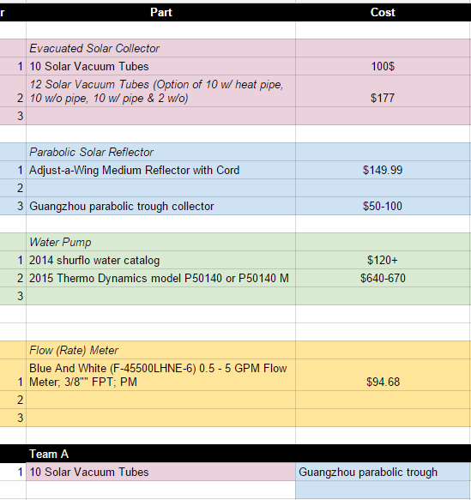

Bobcat Day!

One of the highlights of the semester was participating in BobCat day, in which the team presented the project to incoming freshmen. The BobCat day team, Joseph, Josh, Hang, Fatima, and Jacob presented a cardboard model of the solar collector which was built for Bobcat Day. The team informed students of the Engineering Service Learning course as a whole, as well as the Instructional Lab 2’s solar collector project. One aspect that was emphasized by the team was that the course is not meant only for Engineering majors, and that all types of people are welcomed. The team also demonstrated their understanding of the project and the future impact it could make.

[3]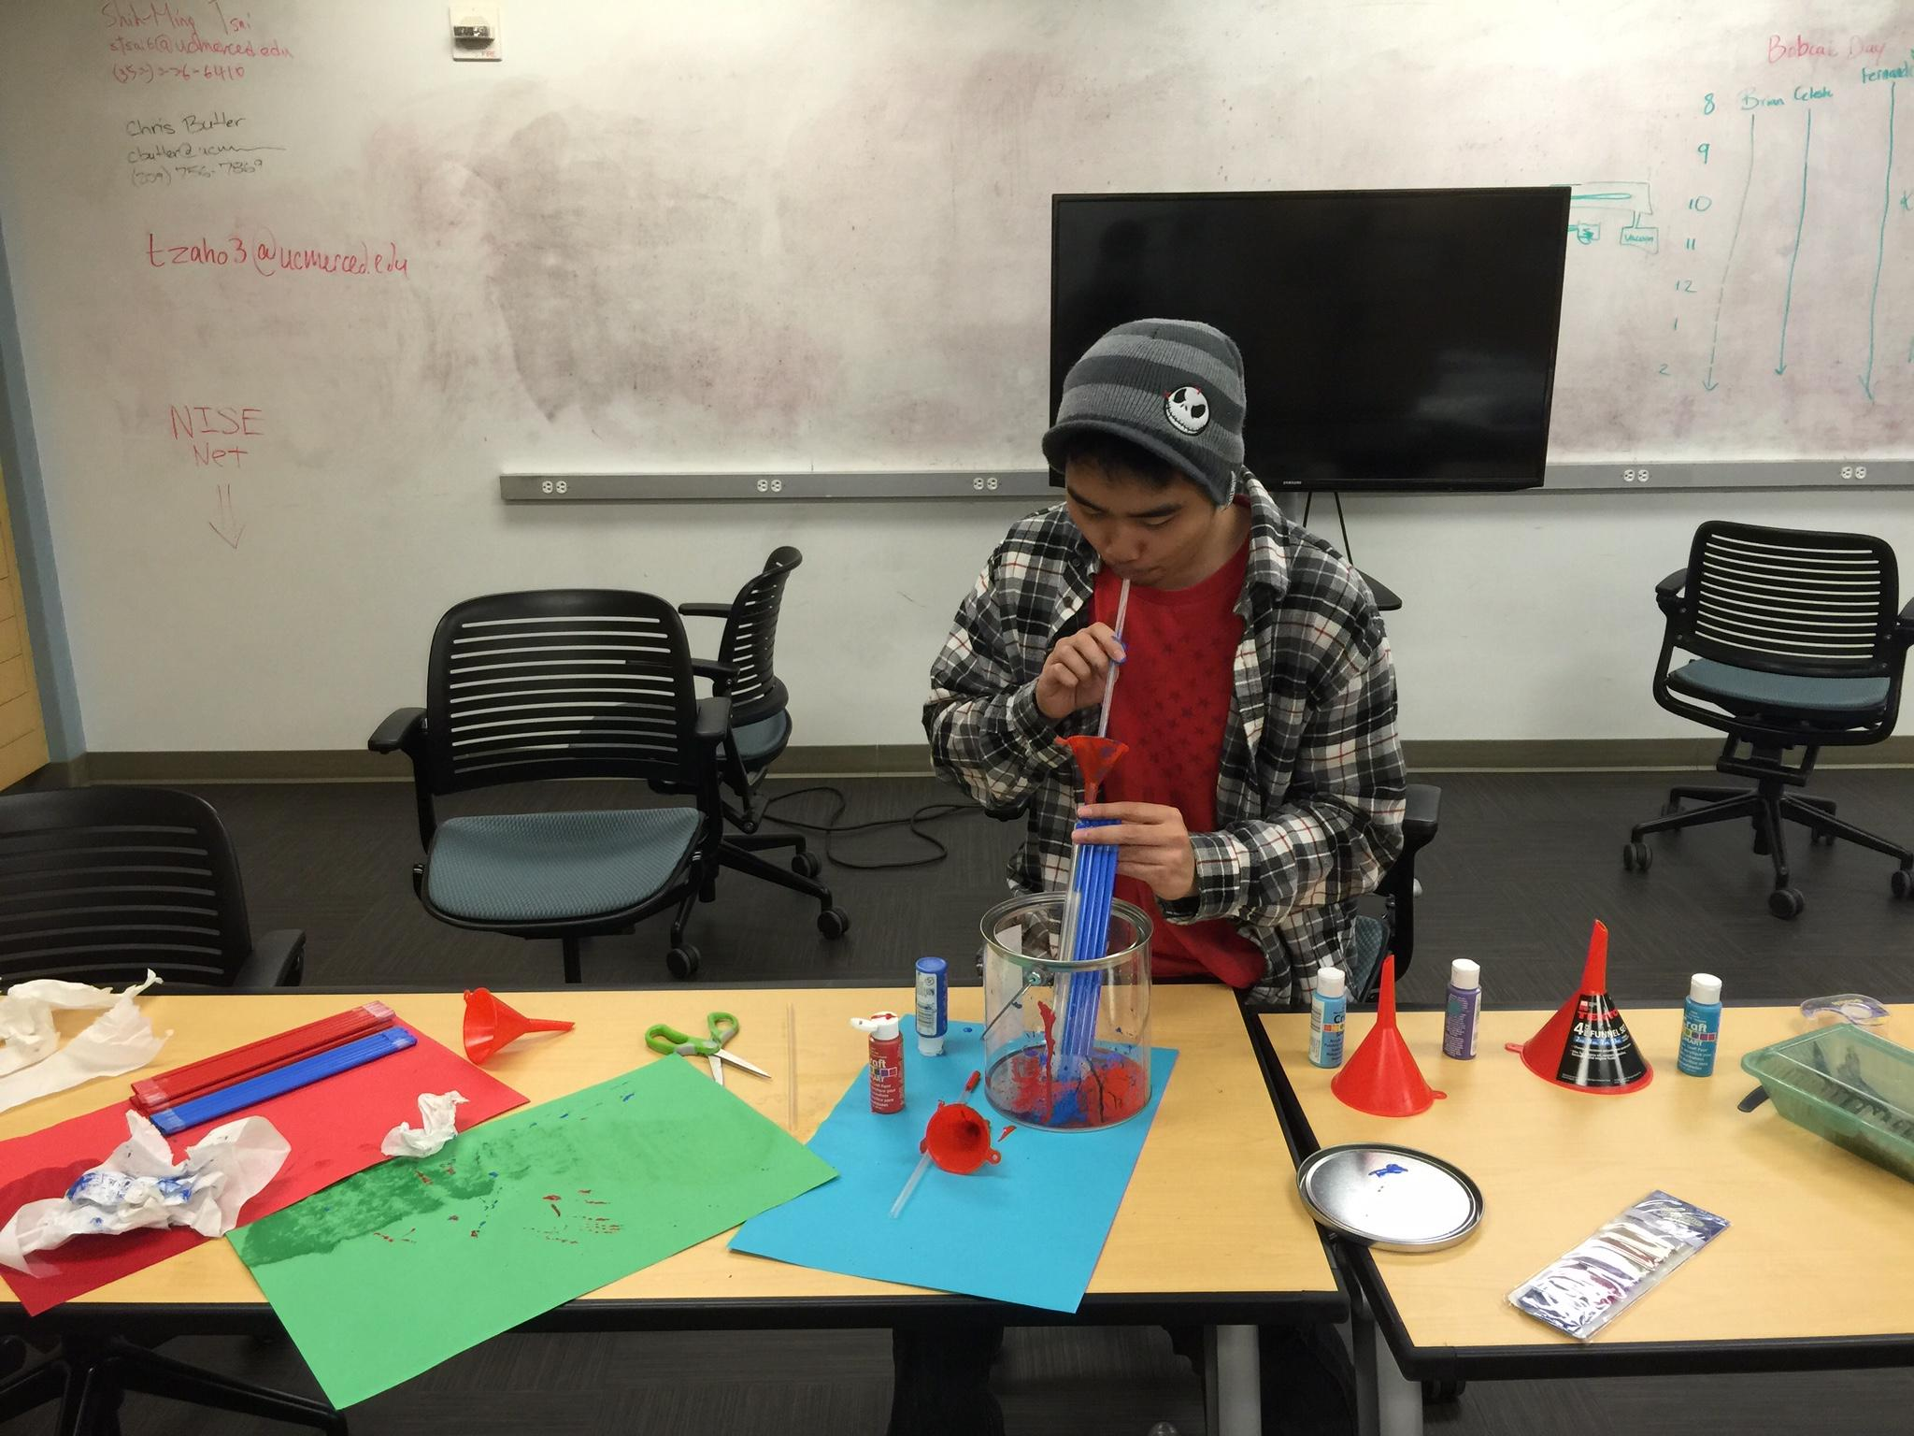

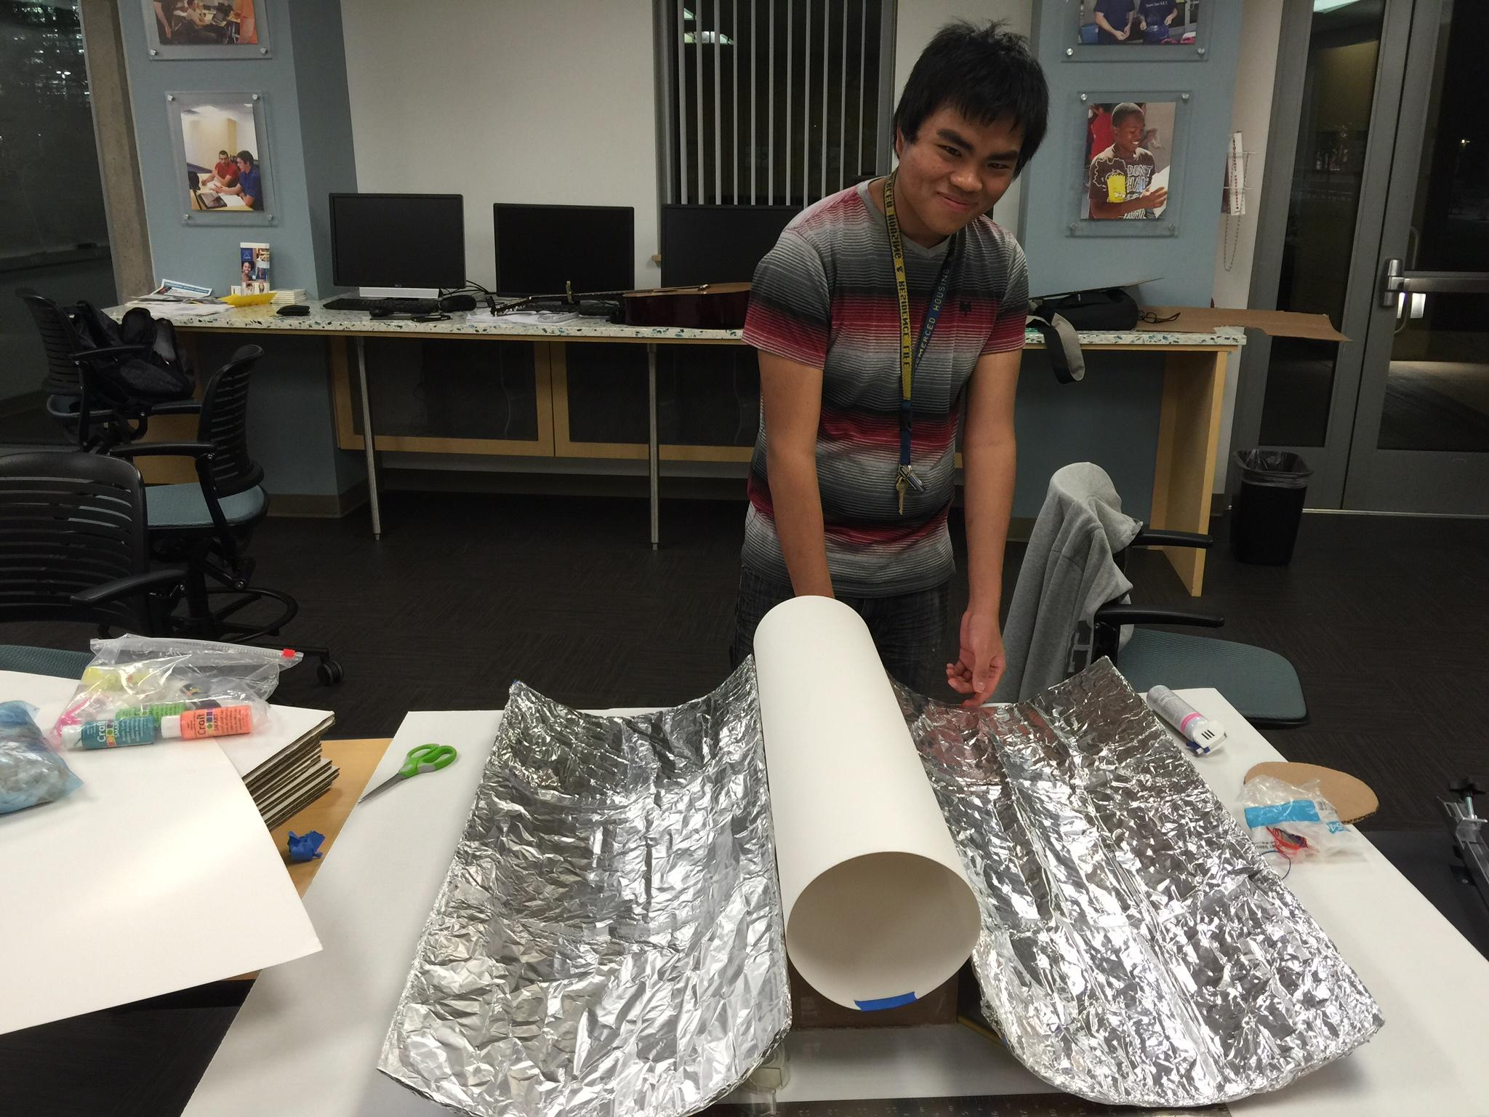

Transition/End

Unfortunately, due to changing circumstances, the team did not get to complete a working prototype of the solar collector, but instead did complete the goal of ordering parts to build a working model which can be used to advance next semester’s work. In order to make this transition as smooth as possible, the team will provide clear updated files for the next team to read which will include all relevant information, the steps we took to achieve our goals, and where they should focus their efforts on. Hopefully next semester will incorporate more team members so that we can be more efficient in dividing and assigning tasks and to make sure deadlines can be met. Since a lot of time was spent on actually learning about solar collectors, next semester’s team should make this phase shorter and start focusing on building. Hopefully this document can help shorten this part of the semester.

1. From the left Majok, Jacob, and

   Josh
2. Team members Jacob, Joseph, Joseph, Juan, Majok, Hang, Josh and Fatima meet with Sergio for a tour
3. Josh (above) Joseph (below) working on the Bobcat Day solar collector model.